For your second digit find out some facts about Scotland.
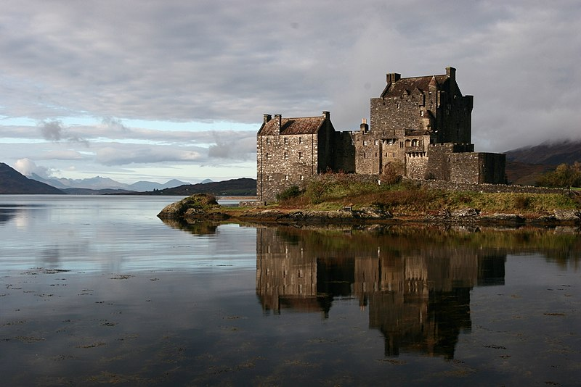
Eilean Donan Castle: Sonja Pieper from Karlsruhe, Germany, Eilean Donan Castle at Loch Duich, CC BY-SA 2.0
- Go to the website: https://www.scottishtours.co.uk
- Click on ‘50 Scottish factoids’, ‘Scotland A-Z’ and then ´Icons and symbols´. Read the information and complete the puzzle.
1. Edinburgh is the capital city of Scotland, but
- Glasgow (1)
- Dundee (2)
- Aberdeen (3)
is bigger in terms of population.

2. Scotland is the northern section of the United Kingdom. It covers an area just
- over 20,000 square miles (1)
- over 30,000 square miles (2)
- over 40,000 square miles (3)
which is about 1/3 of the total UK landmass.

3. The Scottish mainland has the sea on three sides, and there are few places in
Scotland more than:
- 100 miles (1)
- 60 miles (2)
- 40 miles (3) away from saltwater.

4. Edinburgh was the first city in the world to have its own fire brigade.
It was formed:
- in 1824 (1)
- in 1470 (2)
- in 1970 (3) after a series of terrible fires in the historic old town.

5. Nobody has ever seen this animal. It’s a Scottish symbol:
- a Scottish sheep. (1)
- a Scottish unicorn. (2)
- a Scottish Highland cow. (3)

6. The six officially recognised cities in Scotland are: …
- Aberdeen, Glasgow, Edinburgh, Dundee, Inverness and Stirling.(1)
- Aberdeen, Glasgow, Edinburgh, Dundee, Liverpool and Manchester.(2)
- Belfast, Birmingham, Aberdeen, Glasgow, Edinburgh and Stirling.(3)

7. The Scottish wildlife includes three special birds. The largest bird of them is the
- osprey(1)
- white-tailed sea eagle (2)
- red robin (3)

8. In Scotland you can find the highest mountain in the UK: Ben Nevis. It is:
- 1045m (1)
- 1145m (2)
• 1345m (3) high.

9. Scotland has 790 offshore islands,
- 30 of which are inhabited (1)
- 130 of which are inhabited (2)
- 230 of which are inhabited (3).

10. Scotland’s Orkney Islands are made up of:
- 70 (1)
- 80 (2)
- 90 (3) islands.
The Orkney islands are a combination of ancient history, wildlife (dolphins and orcas), beautiful scenery (cliffs and coastlines) and natural phenomena (the Northern Lights).
Geographically, the Shetland Isles are closer to the capital city of Norway than to the capital city of the United Kingdom.

1 | 2 | 3 | 4 | 5 | 6 | 7 | 8 | 9 | 10

Now add up the numbers: 1+2+3+4+5+6+7+8+9+10=….. Leave out the first number (): YOUR SECOND DIGIT IS _______.

